**Unix commands (cont..)**

Job: display working file. Like stopping or running or no files running.

Bg %1: background display. (Job number)

Fg %1: foreground display.

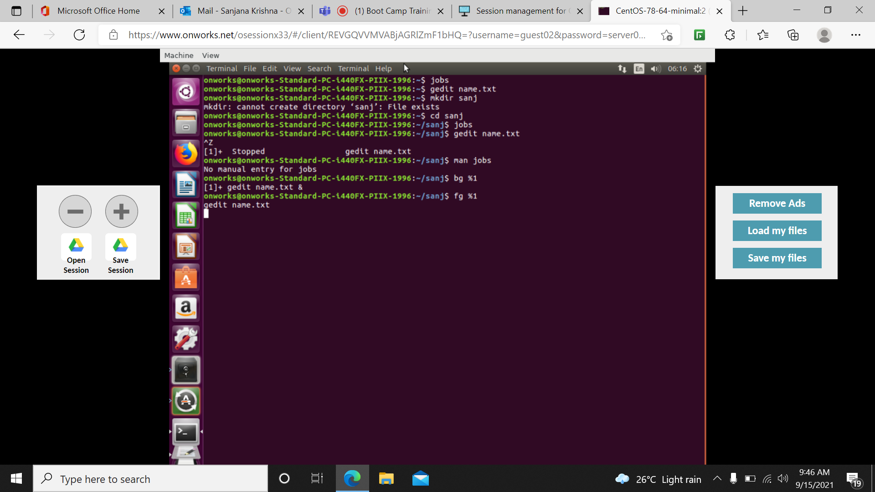

Tail –n +7 fn: prints from the line 7

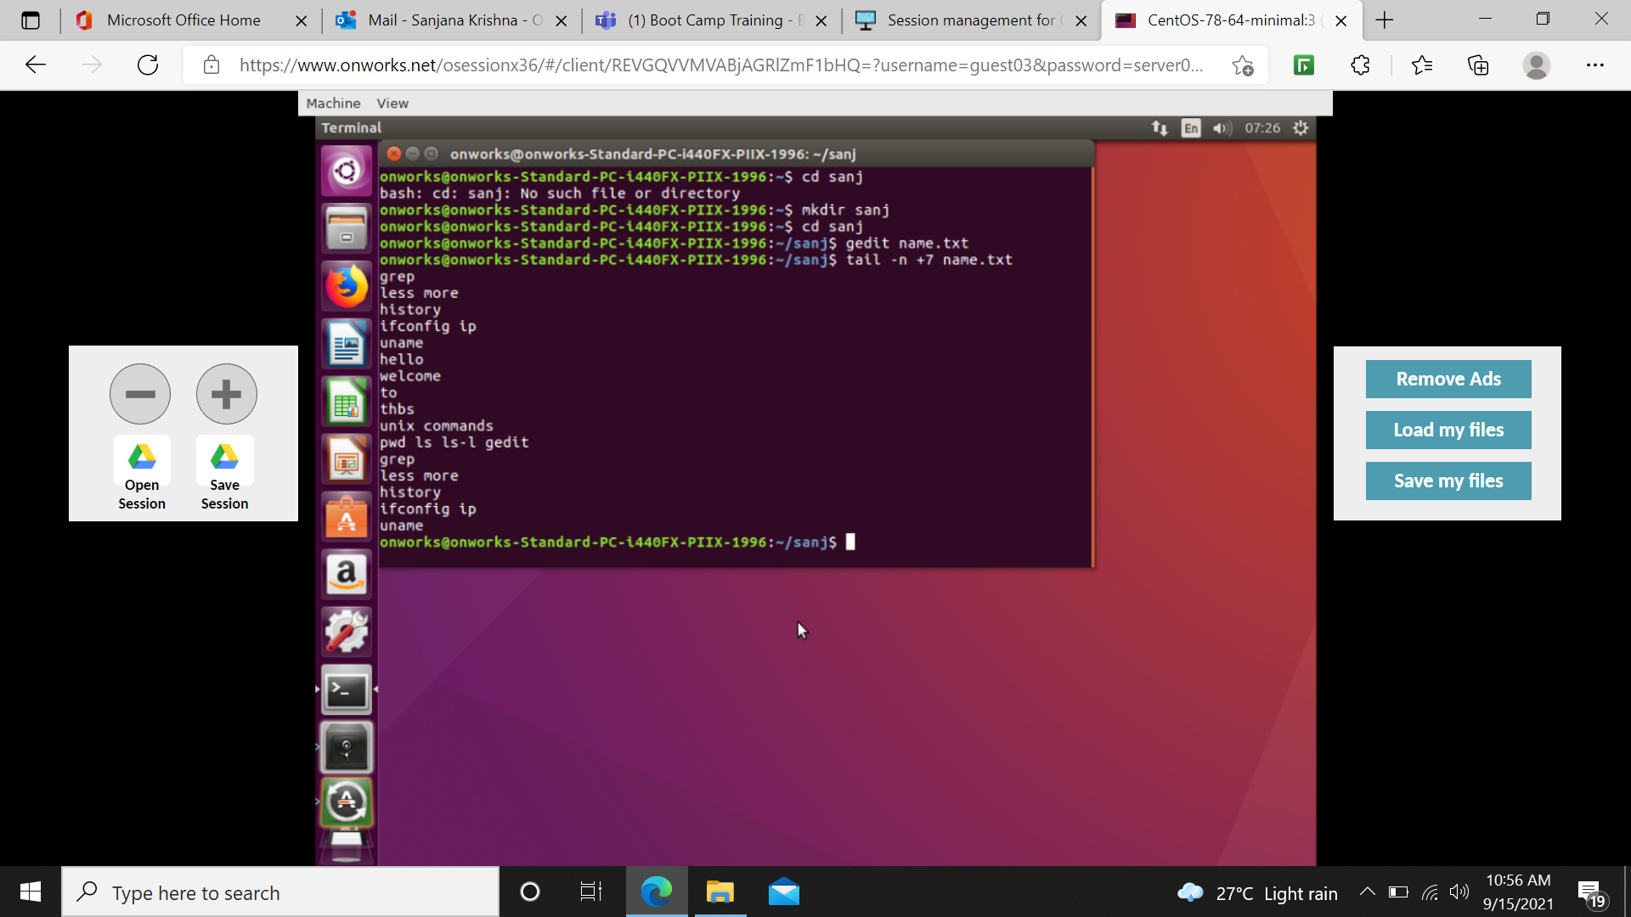

Cat name.txt | head –6 | tail –3 : Display the content from starting 6 lines to ending 3 lines

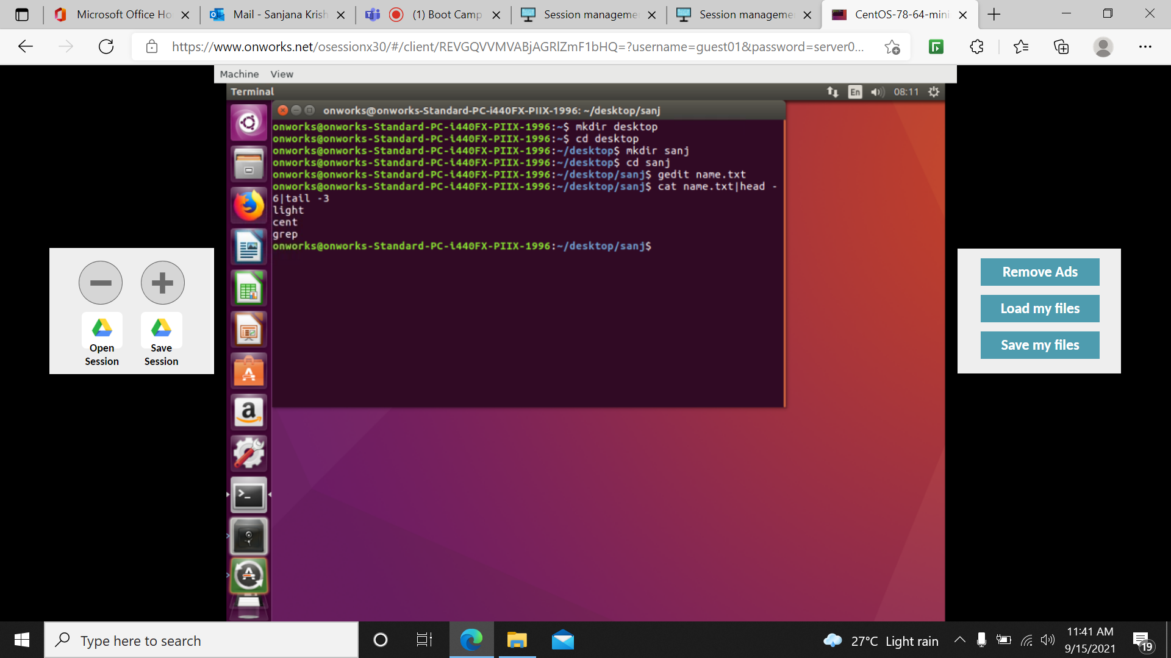

Tail –c +6 fn: display the content from 6th character

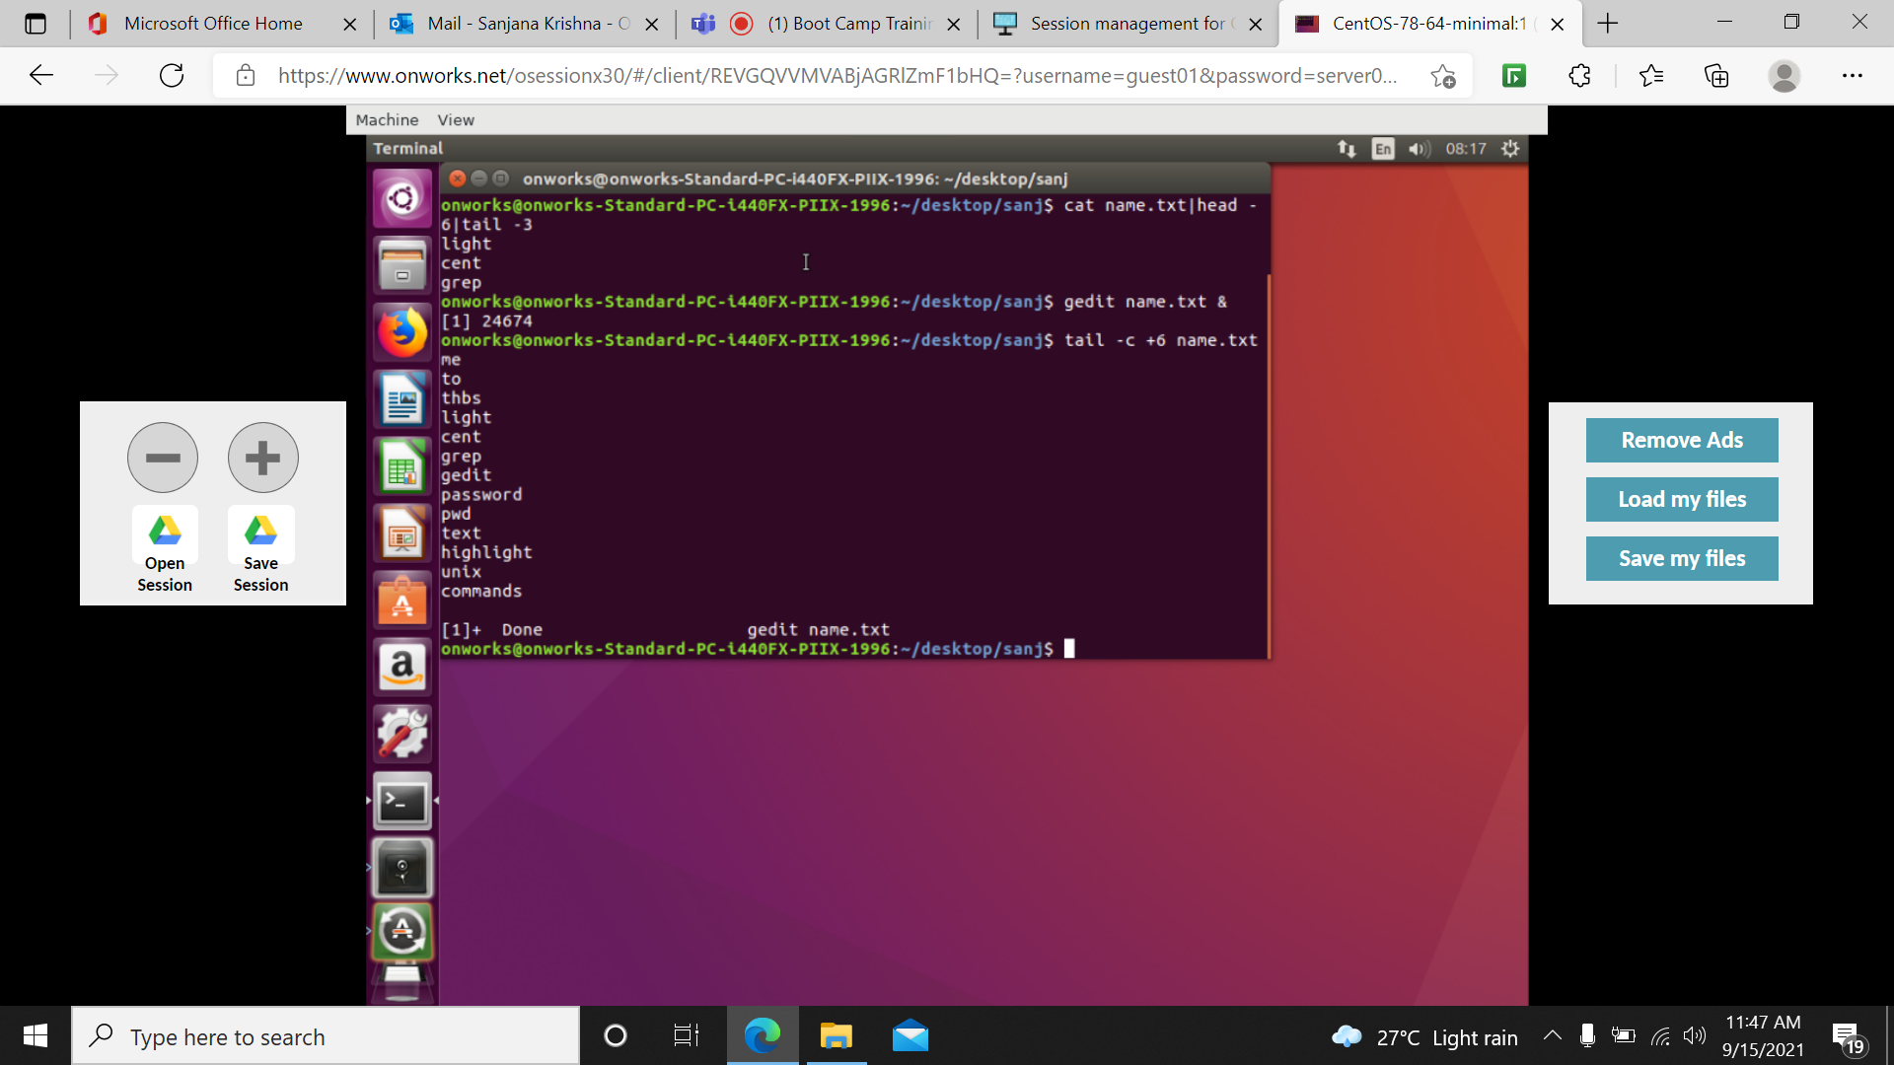

Head name.txt demo.txt demo1.txt: displays all the contents from all the files with file name.

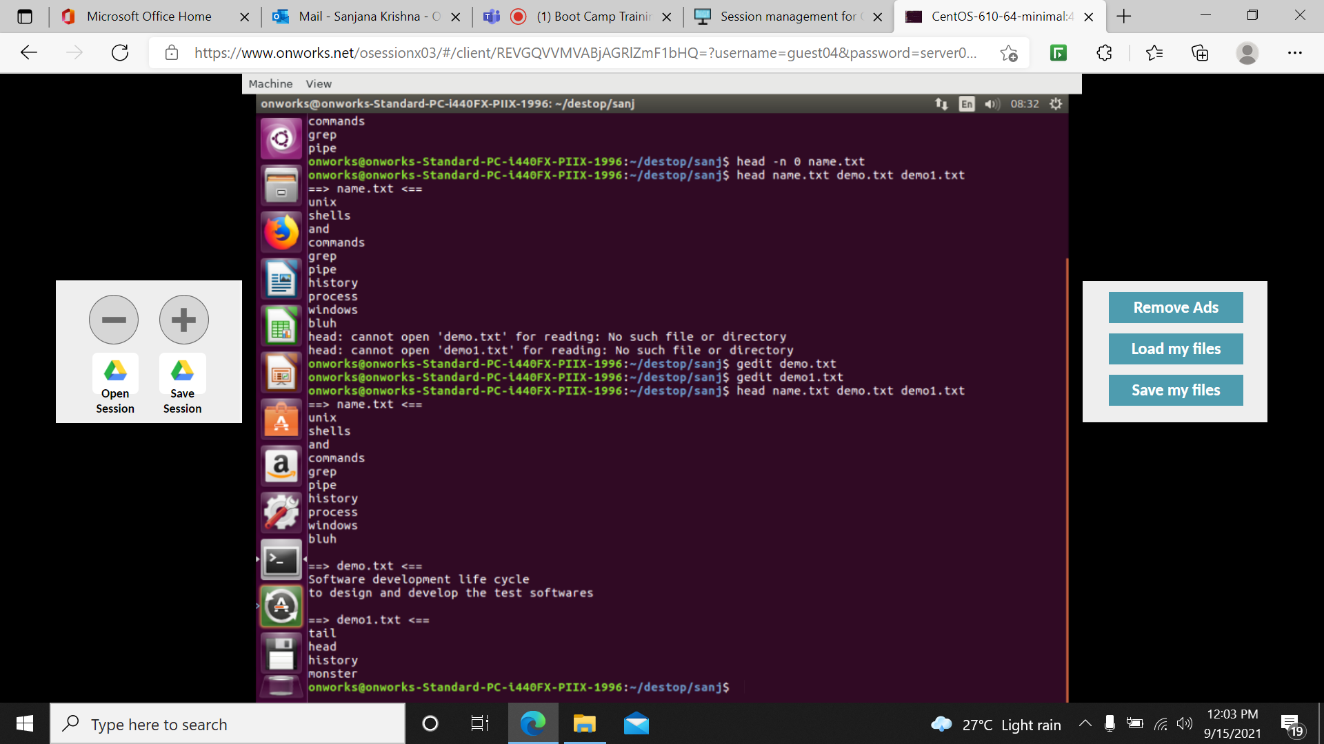

Ls /etc: lists all files with the contents of the directory.

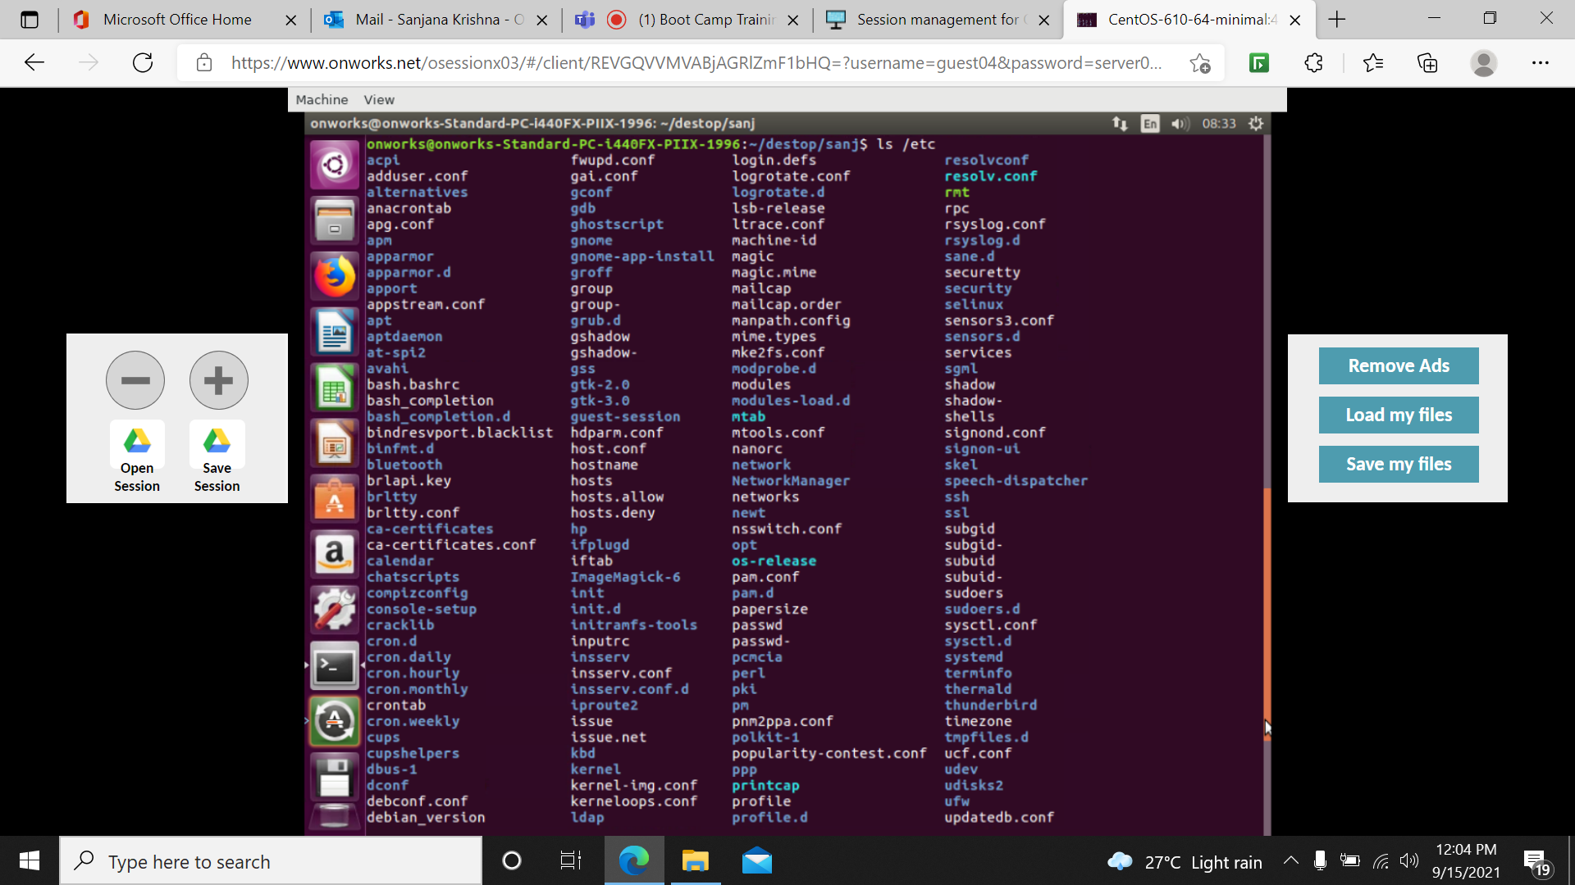

Head name.txt| sort : sort in aphabetical order

Head –version: tells the version

Head –c 5: prints from 5th character

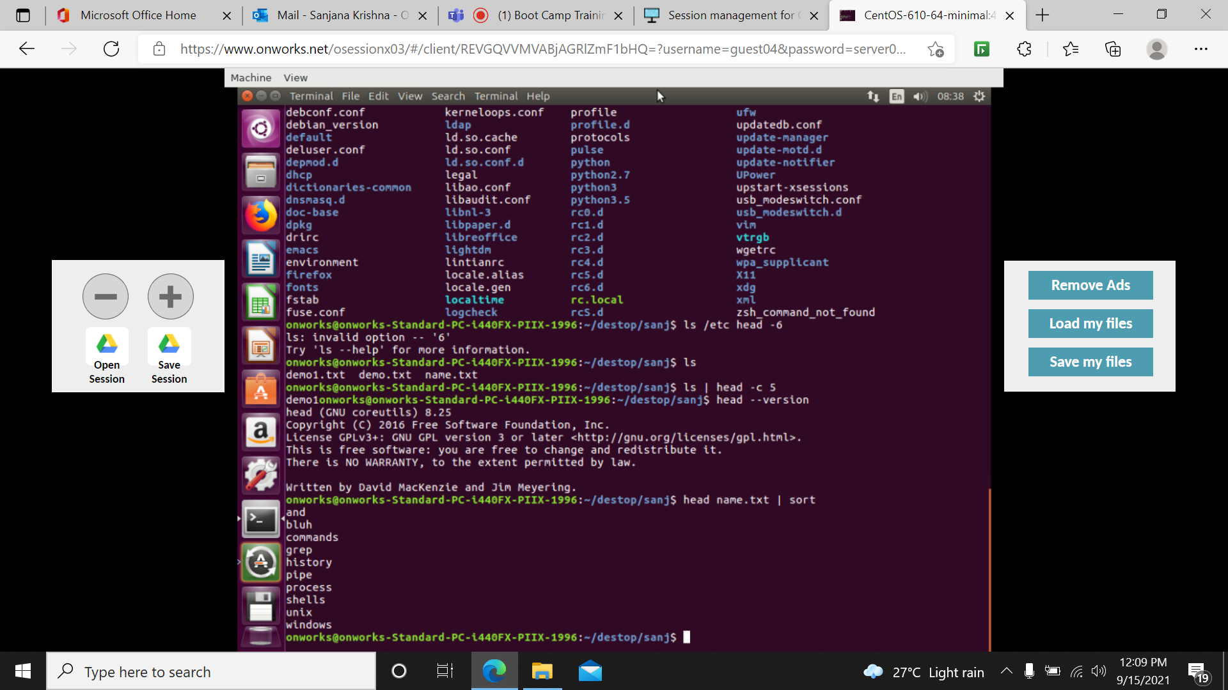

Head –n –7 fn :prints from last 7th line

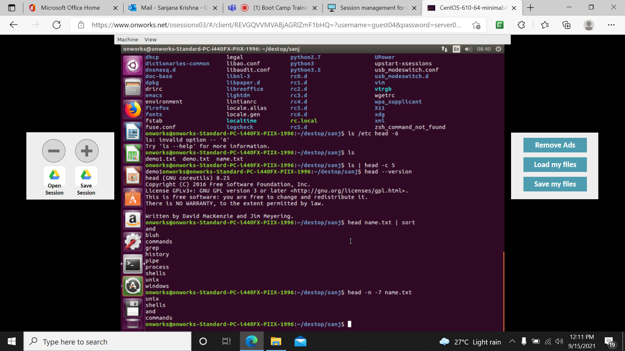

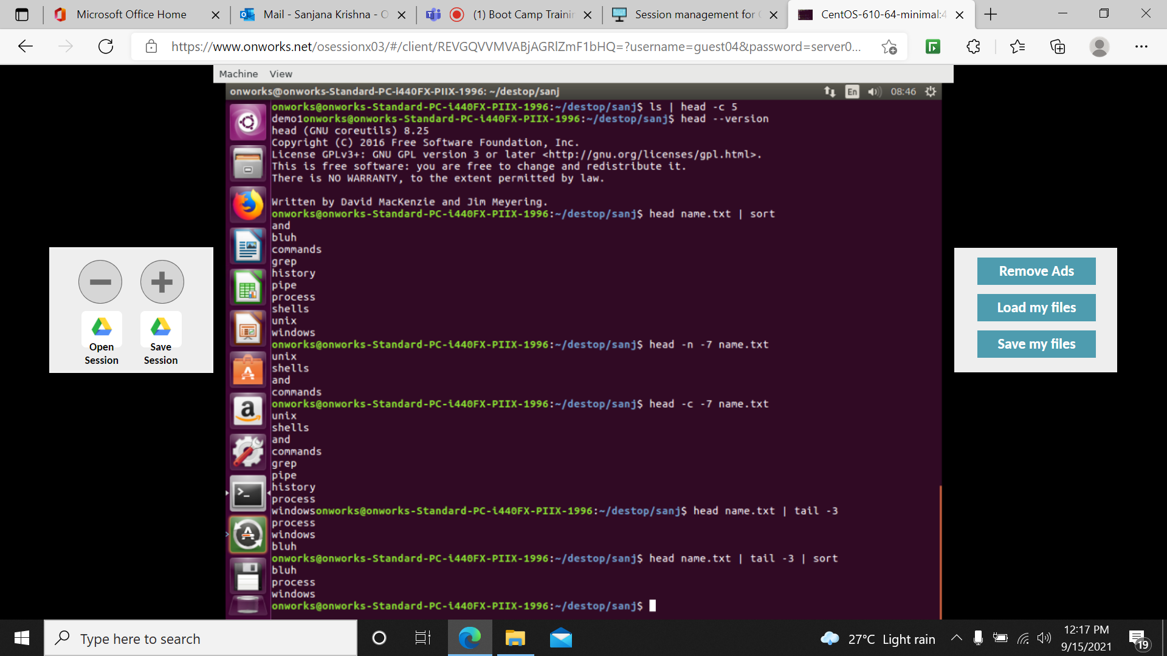

Tr –d: translate or deleting characters

[a-z] - lower case [A-Z] - upper case [:digits:] - digits

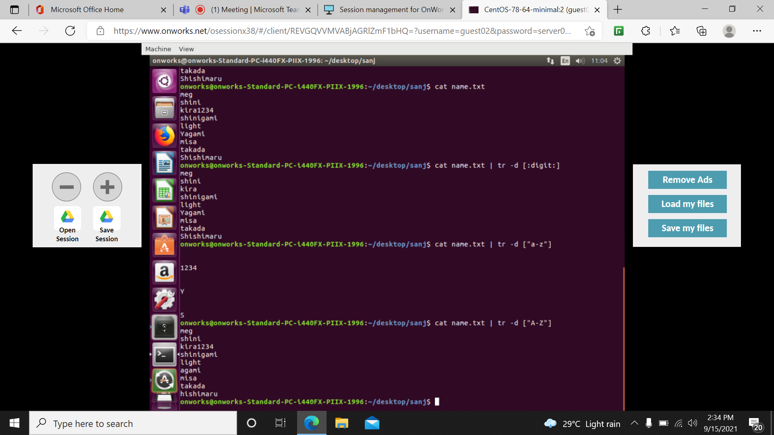

Echo: display the text or string on command line

Tr –s ‘ ‘ ‘ ‘ - replace in one line

Tr –s ‘\n’ ‘ ‘ - shows in one line

\t ‘ ‘- tab space

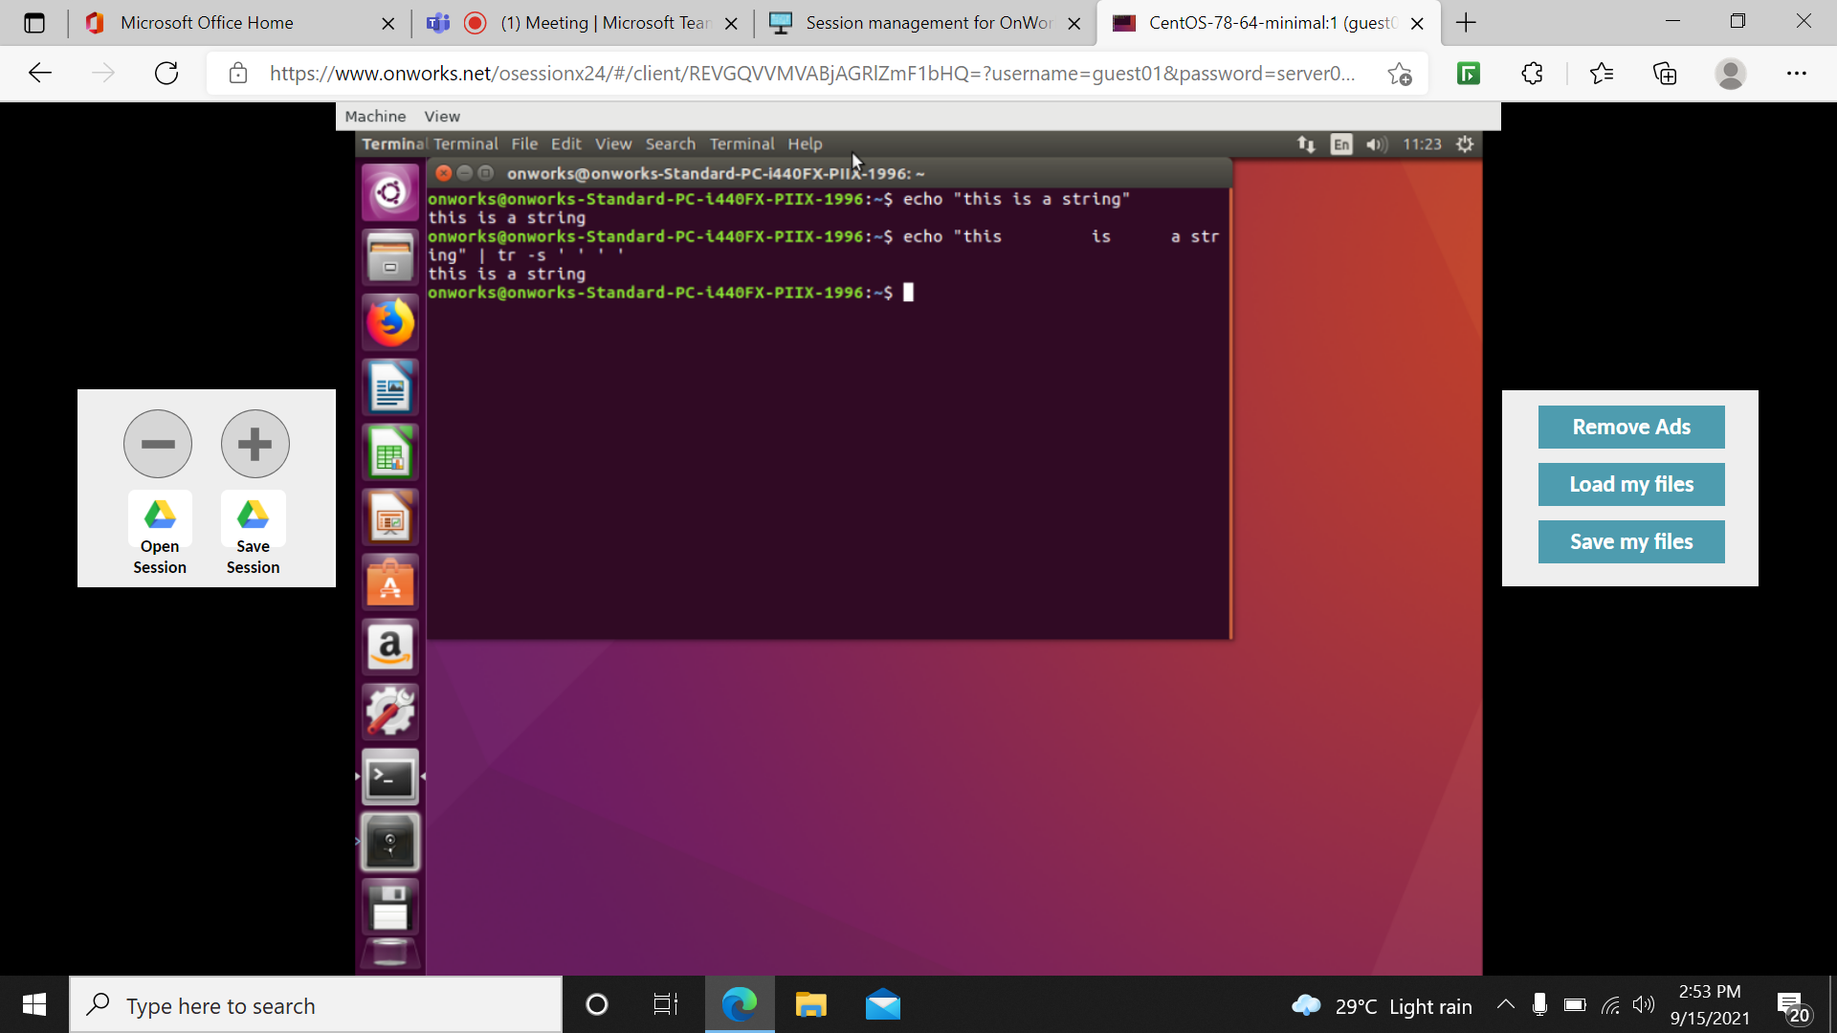

Tr ‘@’ ‘!’ - r - replace

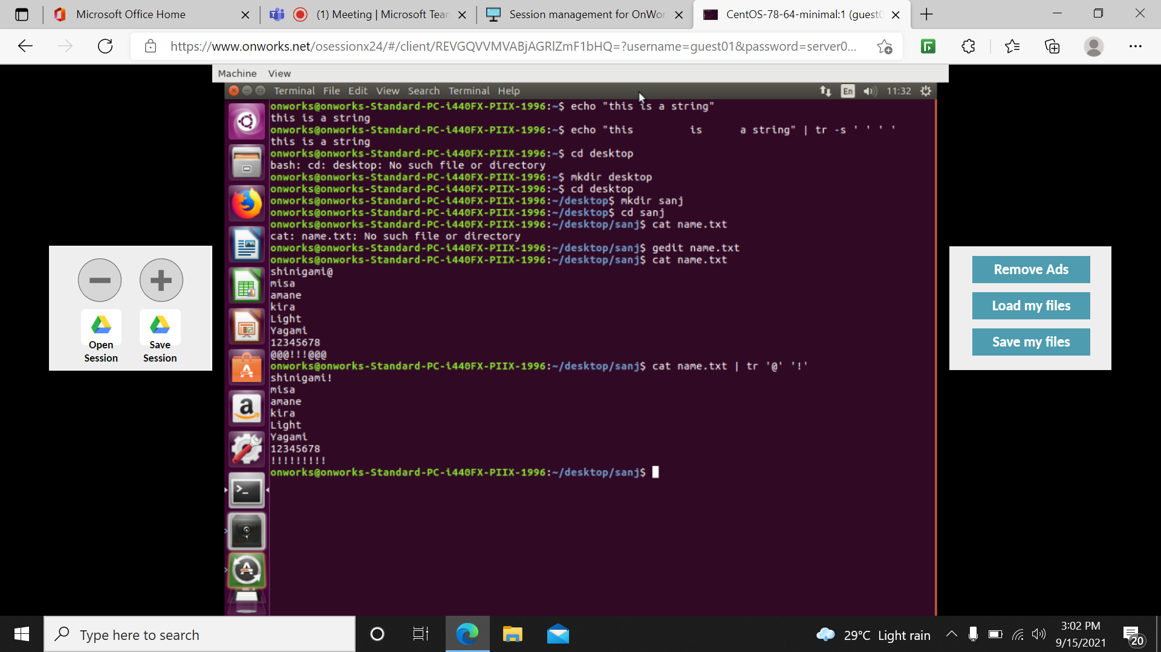

Awk/mawk - pattern scanning and text processing language//eliminate repeated digit or character

Awk ‘!a[$0]++’ - eliminates the repeated word

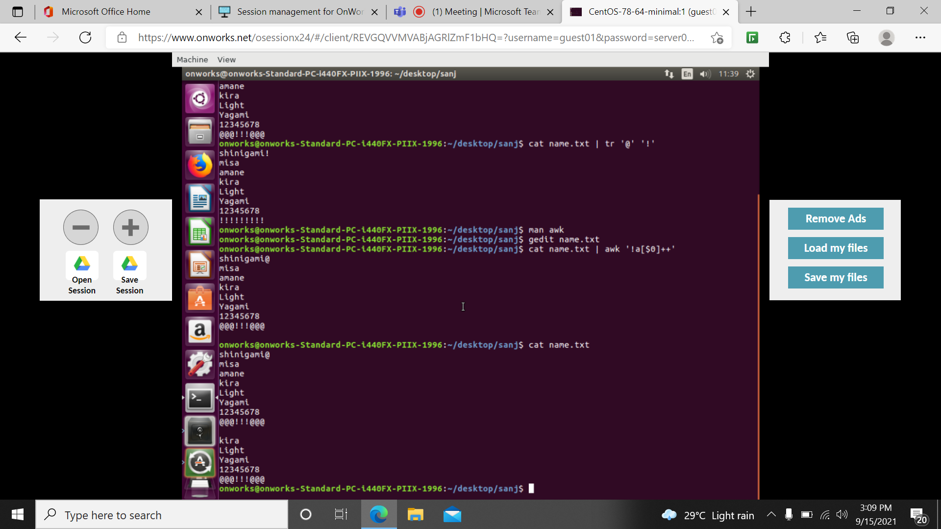

Tree –a/ - list contents of directories in tree-like format

